Identification of an Unknown - B
Faith Williams
11/30/23
CHEM 2081 – 007

Introduction
Identifying an unknown sample can be done in three different ways: NMR, FTIR, & MS. Each of these methods have their own strengths and weaknesses, and knowing how to efficiently identify an unknown by utilizing these methods is an important skill when wanting to confirm the results of a conducted experiment.
Theory
The first method is known as Nuclear Magnetic Resonance (NMR). NMR is performed by using frequency waves to observe the resonance between different magnetic energy levels.
The second method is Fourier Transform Infrared Spectroscopy (FTIR). FTIR is consisted of two spectroscopic techniques: Infrared (IR) Spectroscopy and Mid-Infrared. IR Spectroscopy is used for chemists to know if the organic compound they are working with has simple functional groups or not. IR energy is passed through the organic compound and absorption bands are the product of interest. The Mid-Infrared region is anywhere between 4000 to 600 cm⁻¹ and is where absorptions appear usually.
The third method is Gas Chromatography and Mass Spectrometry (GC-MS). GC-MS shows the base peak and then the molecular ion peak values, giving us the ability to figure out the molecular formula and the M+ pattern of the peaks.

Data

NMR
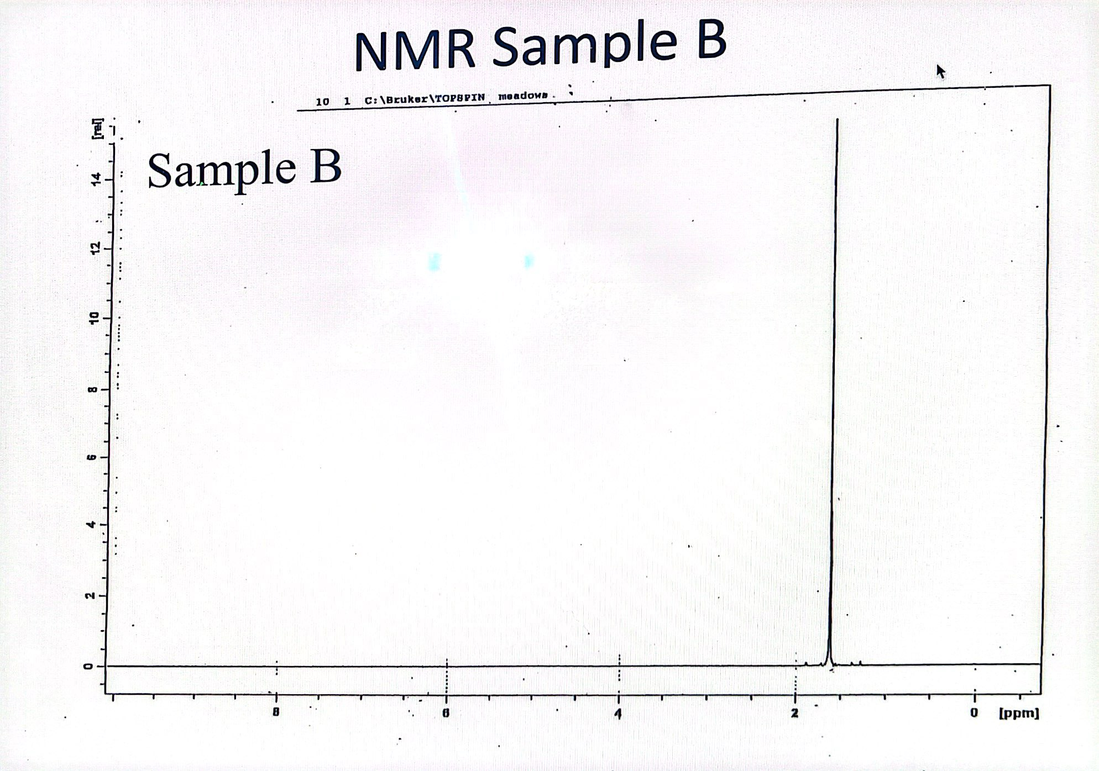

FTIR
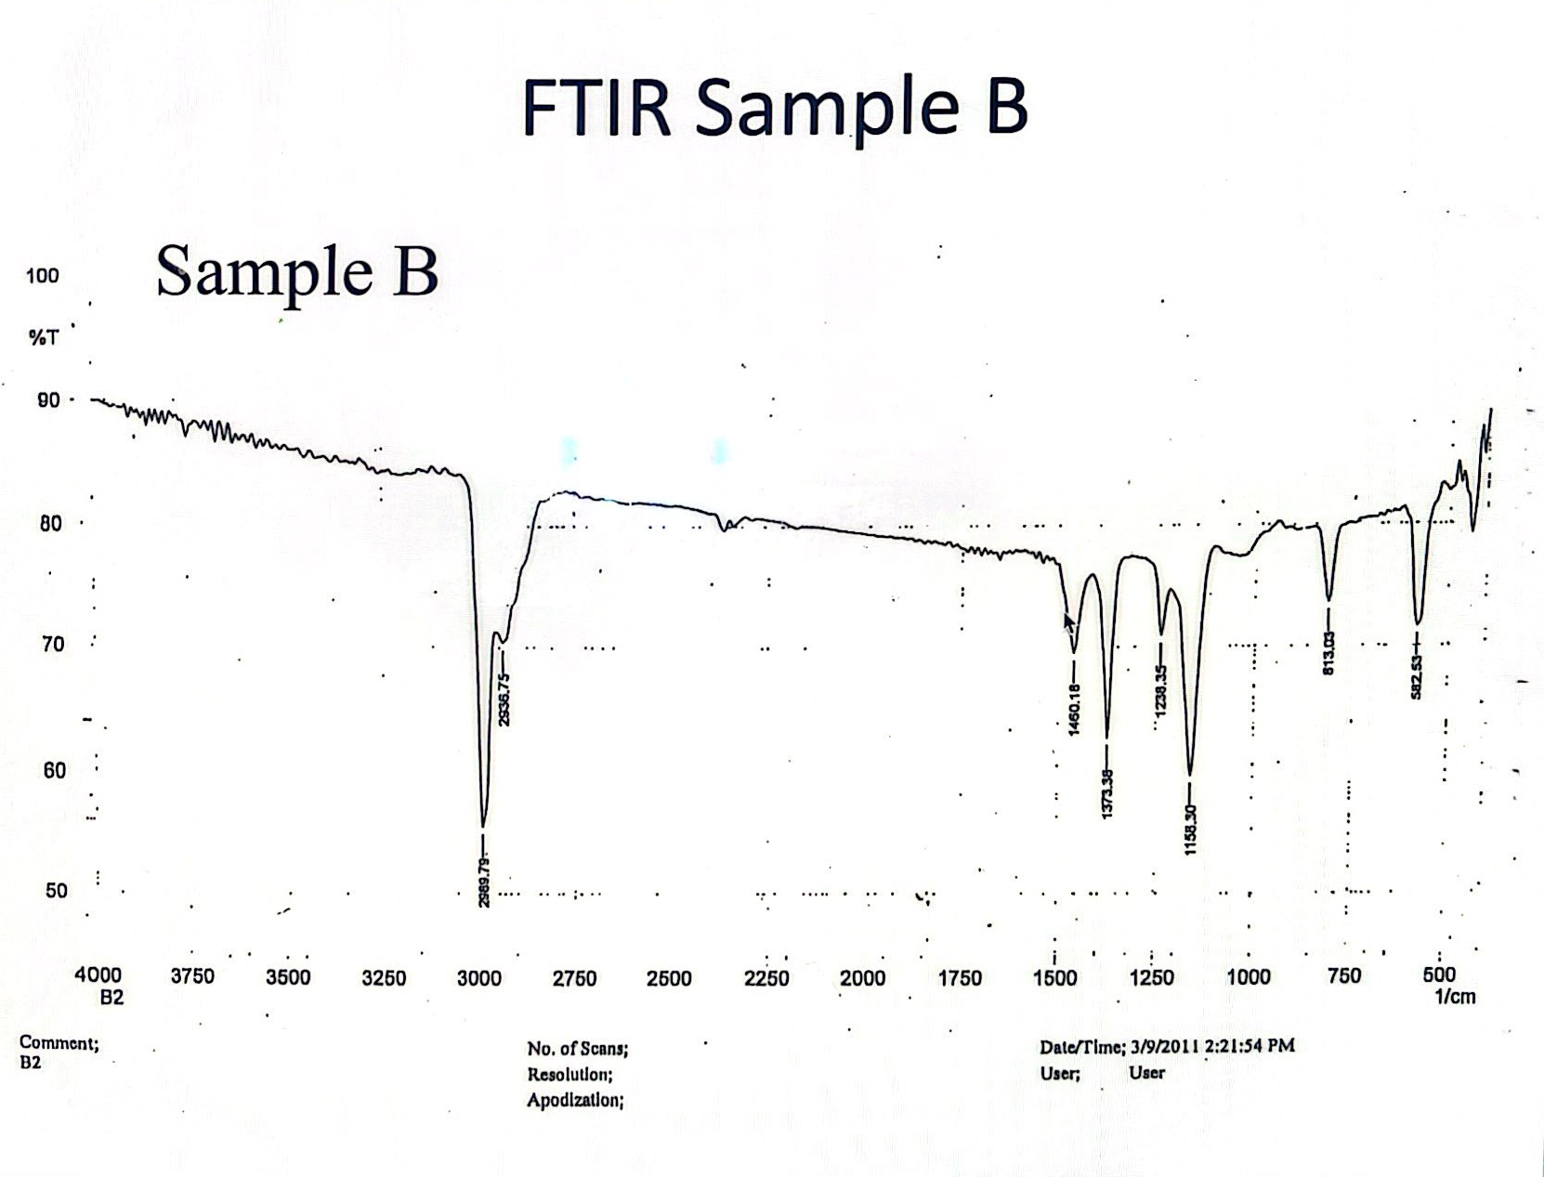

GC-MS
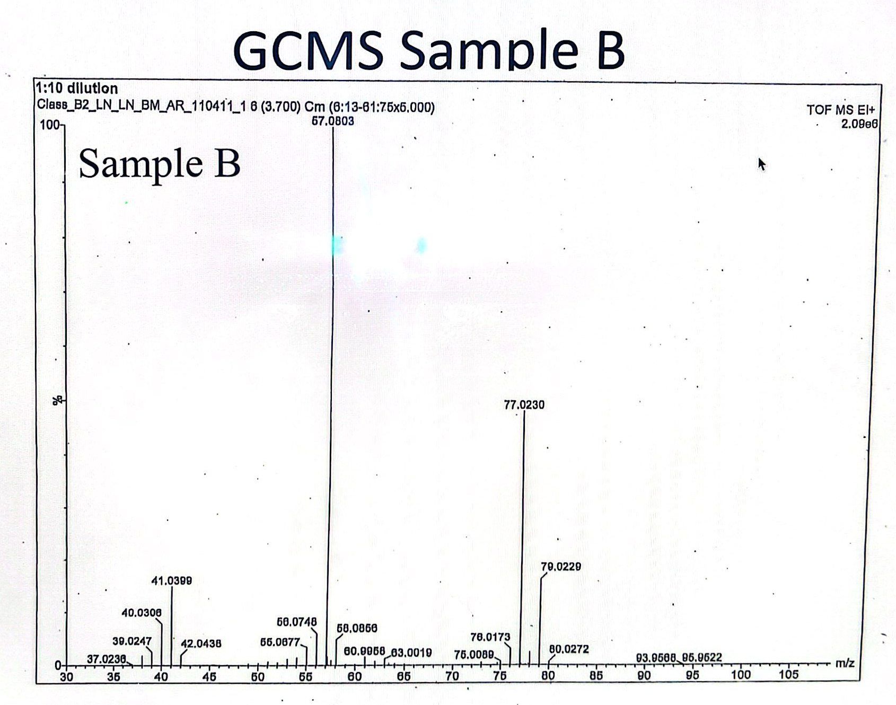
Analysis
In the NMR spectrum given, it is observed to only have one signal, being a singlet. The singlet has a high frequency occurring at approximately 1.6 ppm. This singlet in this NMR spectra shows similar patterns as Figure II-7, in the Organic Chemistry II lab manual, with a common factor intending the likely presence of a tert-butyl group within the unknown.
The IR Spectra shows the small differences in compounds that may seem very similar in other tests. This allows us to identify the functional group region, fingerprint region, and the aromatic region. The functional group region occurs from 4000 – 1500 cm⁻¹ and shows strong peaks of most functional groups. Sample B IR spectra shows two peaks within this functional group that happen at approximately 2989.79 cm⁻¹ and 2936.75 cm⁻¹. The fingerprint region is between 1500 – 900 cm⁻¹ and is usually complex. Sample B shows four visible peaks in this region occurring at 1460.18 cm⁻¹, 1373.38 cm⁻¹, 1238.35 cm⁻¹, and 1158.30 cm⁻¹. Lastly, the aromatic region is between 900 – 600 cm⁻¹ and shows the substitution patterns of benzene and other common aromatic compounds and supporting information about the structure of alkenes. Only one visible peak is within this region, and it occurred at 813.03. Based on this data we can say that the two peaks within the functional region show to have the vibration pattern of an Alkane C-H stretch with a intensity of m to s. The four peaks within the fingerprint region tell us that the two peaks occurring at 1460.18 cm⁻¹ and 1373.38 cm⁻¹ show the vibration an Alkane C-H bend with a m to w intensity, and the other two peaks at 1238.35 cm⁻¹ and 1158.30 cm⁻¹ show the vibration pattern of an Amine C-N stretch with an intensity of m. Lastly, the one peak within the aromatic region can be categorized as having a vibration pattern of a aromatic compound C-H bend with a intensity of s.
The Gas Chromatograph and Mass Spectrometry shows a base peak of approximately 57.08. Knowing the m/z is approximately 57, we can say there is a possible fragment of C₄H₉. This also contributes to the idea from the NMR of there being a possible tert-butyl group present. We can also factually say that from the results of the MS graph the molecular ion peak is approximately 77. Observing the M+2 peak pattern closely after the molecular ion peak, gives suspicion of an isotope(s). A large peak in this M+2 pattern is a good indicator of a bromine or chlorine isotope and can be determined which one by assessing their relative intensities. This GC-MS data supports the presence of a chlorine isotope within this unknown.

Conclusion
After thoroughly analyzing all three tests, it is factual to say that this unknown compound is tert-butyl chloride. The NMR test showed only one peak indicating a singlet, which indicates a tert-butyl group. The GC-MS test showed a M+2 pattern which indicated the presence of bromine or chlorine isotopes, and after comparing their relative intensities it was concluded that the unknown consisted of a chlorine isotope. It was then confirmed to say that based on these three tests, the unknown B sample is 2-chloro-2methylpropane or known commonly as tert-butyl chloride.
References
Keller L, Joseph K, and Miguel S. 2023 Fall. CHEM 2081 Organic Chemistry II Lab
Manual [lab manual]. Auburn (Al): Auburn University.

